**ONLINE GROCERY SHOPPING**

**Component Name: Dashboard**

**Description:**

**The Dashboard is a central interface for administrators or store managers to manage and monitor the online grocery platform. It provides a comprehensive overview of system activities, including sales metrics, user management, product listings, orders, and inventory status. This component helps make quick decisions by displaying real-time data using charts, tables, and alerts.**

**CRUD Operations:**

**1. Create:**

* **Add new products to inventory**
* **Add discount offers or promotional banners**
* **Add new categories or suppliers**
* **Register new admin/staff accounts**

**2. Read (View):**

* **View sales analytics and reports**
* **View product listings with stock levels**
* **View customer profiles and behavior**
* **View current and past orders**
* 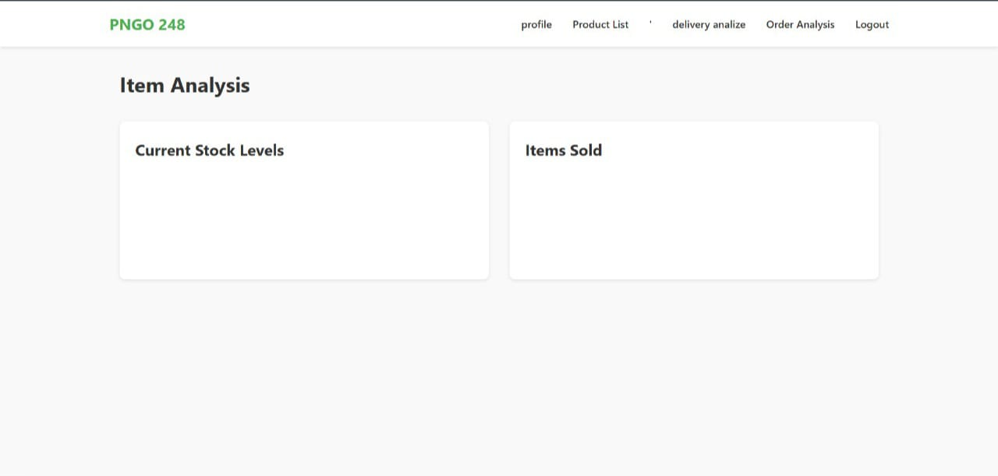**Monitor dashboard widgets**

